Introduction

Overview

The AddonSoftware Accounts Receivable module provides invaluable information for managing your customer base, making credit decisions and improving cash flow to your business. This manual introduces you to the capabilities of the software, helps you install and operate the software with the guidance of your dealer, provides complete processing instructions and serves as a reference guide for all menu options and data entry fields. The manual is divided into four main sections:

Introduction
This section provides an overview of the Accounts Receivable features, a list of standard reports and registers and a flow chart of system processing.

Installation
This section provides information primarily used by your dealer when installing the software. The information included will help you gather the required information, make the right decisions for setting module parameters, enter the information gathered and convert from manual to computerized accounts receivable processing. Data collection forms are provided which can be used to gather the information and as a record of how the module was established.

Flow of Processing
This section consists of step-by-step procedures for daily and monthly processing within the module. A processing checklist is also provided that should be referenced regularly when operating the Accounts Receivable module.

Accounts Receivable Operations
Included in this section are descriptions and instructions on how to operate each of the Accounts Receivable tasks. Each menu task is explained in the order it appears on the standard software, with descriptions of each field and operator prompts. Examples of report layouts can be found in Appendix A.

Throughout this manual it is assumed that the reader possesses a working knowledge of accounting or will have an accounting professional advise on the installation and operation of the software. It is very important that each of the software installation steps be performed carefully and thoroughly so that the Accounts Receivable module produces the desired results and posts to the General Ledger module correctly.

Optional AddonSoftware Modules
It is beneficial to have the General Ledger module installed when using Accounts Receivable. As part of the update process, Accounts Receivable can make postings to the General Ledger of the sales and cash receipts transactions. It is not necessary, however, that the General Ledger be fully operational with up-to-date “live” balances before operating the Accounts Receivable module.

The Order/Invoice Processing and Sales Analysis modules may also be installed with the Accounts Receivable module, depending on your requirements. Normally, Order/Invoice Processing would be installed in conjunction with the Inventory Control module. The Sales Analysis module collects extensive data on the sales of each item and customer, and other pertinent inventory and receivables related data. It is dependent upon the Order/Invoice Processing, Accounts Receivable and the Inventory Control modules.

When several related modules are used together, such as Order/Invoice Processing, Accounts Receivable, General Ledger, Inventory Control and Sales Analysis, your dealer will work with you and advise on the best sequence for getting the software up and running.

Features and Benefits
The following is a list of standard features included with the software and how they are used in the Accounts Receivable module.

Open Item Receivables
All invoices are maintained individually by the module and may be retained on file after they are paid. You decide how long to retain paid invoices and you have the option to purge them by date.

Flexible Customer Code
A unique alpha-numeric customer code or number ranging from 1 to 6 characters. Customers may also be grouped by type for sales analysis purposes.

Customer Comments
You may store “free text” comments for each customer and inquire into the file at any time. These comments may be used for special shipping instructions, credit information or for any other use, and are displayed automatically when new orders are entered into the Order/Invoice Processing module.

User-Defined Categories
You may define your own salespersons, sales territories, customer types, terms codes, general ledger distribution codes, sales discount codes, sales tax codes, etc. This allows you to easily tailor the module to the way you do business.

F3 Lookup
The F3 function key is available in most tasks as a means of looking up customer names, codes and numbers. When looking up customers, they may be located by keying in as much of the name as is known, causing the module to begin an alphabetic customer search beginning with that name. A unique alphabetic search key may be associated with each customer.

Standard Default Information
Each customer is assigned a salesperson, territory code, terms code, ship via request, standard message code, etc. This information is automatically used by the Order/Invoice Processing module, speeding the data entry process.

Customer Retention
Mail order/COD (temporary) customers may be automatically purged after all orders are shipped and invoiced and all balances paid.

Multiple Ship-to Addresses
Each customer may use up to 999,999 alternate ship-to addresses that can be referenced during the order or invoice entry process of the Order/Invoice Processing module.

Detail/Summary Inquiry
You may inquire into the current status of the customer’s outstanding orders either in summary or detail. Also, a complete history of accounts receivable transactions may be maintained for each customer.

Summarized Sales History
Month-to-date, year-to-date and prior year sales, costs, and gross profit information are kept for each customer.

Credit Decision Support
You may assign a different credit limit to each customer that is automatically checked during order entry. Average days-to-pay is calculated automatically for each customer, along with last invoice and payment dates.

Aging Report
You may age customer accounts by any date and print either a detail or summary list of the open invoices. The Aging Report prints in either numeric or alphabetic sequence.

Aging Analysis Report
A special report is included that enables you to select customers by specific aging criteria, such as average days-to-pay or receivables balance older than a certain date. Summarized sales history is shown for each customer on the report.

Customer Statements
You may print customer statements based on aging information for selected customers. Finance charges may be applied selectively to past due balances prior to printing statements.

Cash Receipts
You may post cash sequentially by invoice number, apply cash automatically beginning with the oldest invoice or post to a select group of invoices. You may allow or disallow discounts and small balance write-offs as you post. A running balance of remaining cash is kept which must be in balance. Excess cash received or customer deposits may be posted on-account and the amounts applied at a later time. Miscellaneous cash may be posted directly to the general ledger.

Invoice Date Modification
Invoice dates may be modified to correct errors in billing, adjustments or aging. An audit report is provided for all such changes.

Conversion Invoice Entry
You may enter invoices into the system without using the Order/Invoice Processing module, if desired. All general ledger postings are made automatically.

Simple Invoice Processing
Included within the Accounts Receivable module is a complete invoicing process that creates and prints invoices, then updates the customer and general ledger files. Simple Invoicing is not integrated with the Inventory Control module, but still provides a detail invoicing function.

Automatic Customer Numbering
If desired, new customers may be automatically assigned the next available sequential customer number. If this option is activated, manual numbering may still be used. Automatic sequencing is not available for alpha-numeric codes, however.

Multi-Company Capability
Allows you to use the module for more than one company, each with its own separate set of accounts receivable parameters, customers, transaction processing and reporting.

Batch Processing
This feature provides batch processing for groups of transactions in Cash Receipt Entry, Simple Invoice Entry, and Finance Charge Entry.

Reports and Registers
The Accounts Receivable module also includes a full range of reports and registers, providing you with up-to-date information about the current status of the receivables and about data that has just been entered. Following is a list of standard reports and registers:

- Aging Report | - Customer Statements
- Aging Analysis Report | - Customer Type Listing
- Cash Receipts Code Listing | - Distribution Code Listing
- Cash Receipts Register | - Finance Charge Register
- Conversion Invoice Register | - Invoice Date Modification Register
- Customer Detail Listing | - Monthly Cash Receipts Journal
- Customer Comments Listing | - Sales Discount Code Listing
- Customer Cross Reference Report | - Salesperson Code Listing
- Customer Invoice History Inquiry | - Simple Invoice Printing
- Customer Label Printing | - Simple Invoice Register
- Customer Ledger Cards | - Terms Code Listing
- Customer Name Listing | - Territory Code Listing
- Customer Name & Address Listing | - Zero Balance Invoice Report
- Customer Ranking Report

Each register/report is described in more detail in the Operations section of this manual and sample copies are shown in Appendix A.

In addition to these standard features, many of which are parameterized options within the module, your dealer may be able to arrange for custom modifications of the software and tailor it to your specific needs.

Accounts Receivable System Flow
This flow chart shows how the Accounts Receivable module processes data. A detailed description of how the module operates is provided in the Flow of Processing and Operations sections of this manual.

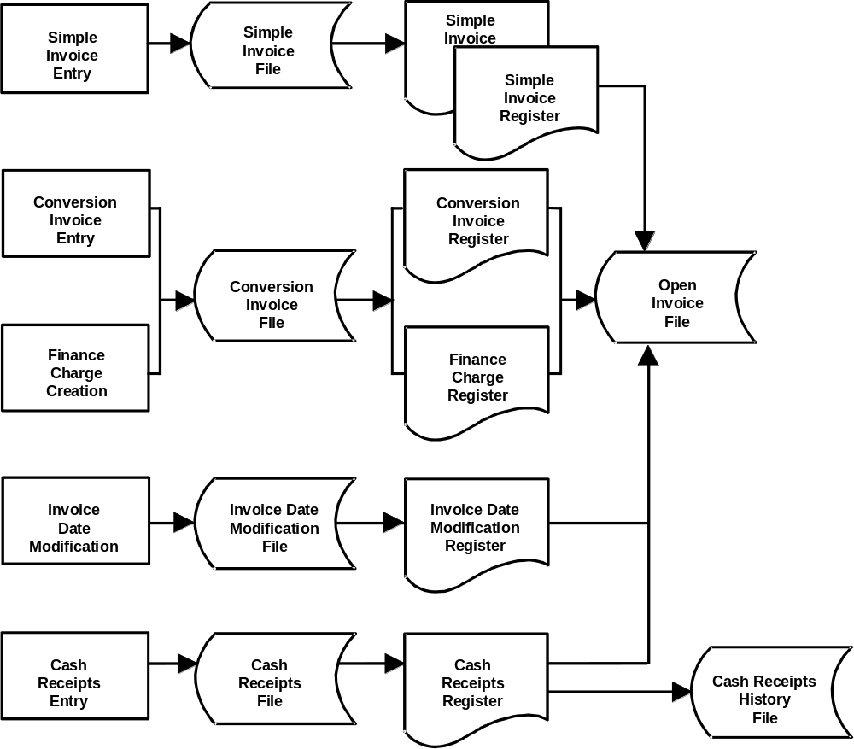

Accounts Receivable System Flow (continued)
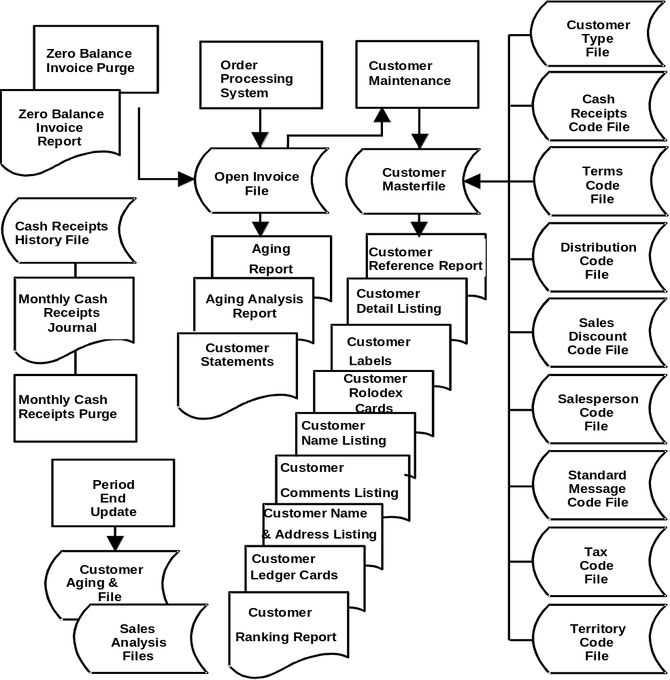

A Word to the User
AddonSoftware wants to keep you updated! Periodic enhancements are made to the Accounts Receivable software and we want you to know about them. To register your software, fill out the Software Registration Form and send it to AddonSoftware at the registration address shown below.

We also want to keep our documentation as up-to-date and relevant as possible. If procedures are missing or not detailed enough for you, they may also be lacking for someone else. Please send us a note describing the problem or question to the documentation address shown below.

A Product Suggestion Form is also provided for you to document any suggestions on how we can enhance our software to make it as relevant to you as possible. We value your suggestions and will welcome them gladly.

For registration, documentation changes or product suggestions:

AddonSoftware
15050 SW Koll Parkway, Suite C
Beaverton, OR 97006
FAX: 503-643-1386
Attn: Product Development

Software Registration Form

Accounts Receivable Module

To ensure that you receive any available updates to your AddonSoftware, as well as other important information, register your software by filling out this form and returning it to the address on the reverse side. Your dealer can help you complete the form.

Your AddonSoftware Dealer’s Name

Your Company Name

Address

City State Zip

Telephone ( )

Your name

Title Date

Please describe your primary business

Number of Employees

Computer Type and Model

Other software used

Comments

AddonSoftware
Sales Services
15050 SW Koll Parkway, Suite C
Beaverton, OR 97006
Fax: 503-643-1386

Remove from binder; fill out other side, fold and mail to address above.

AddonSoftware

Product Suggestion Form
Submitted by: Phone:
Company: Fax:
City: Date:
State: Application:

 Suggestion

AddonSoftware
Product Development
15050 SW Koll Parkway, Suite C
Beaverton, OR 97006

Remove from binder, fill out other side, fold, and mail to address above.

